CPS135B

Consensic

Rev1.1
March 2021
DAT-0030
Data Sheet

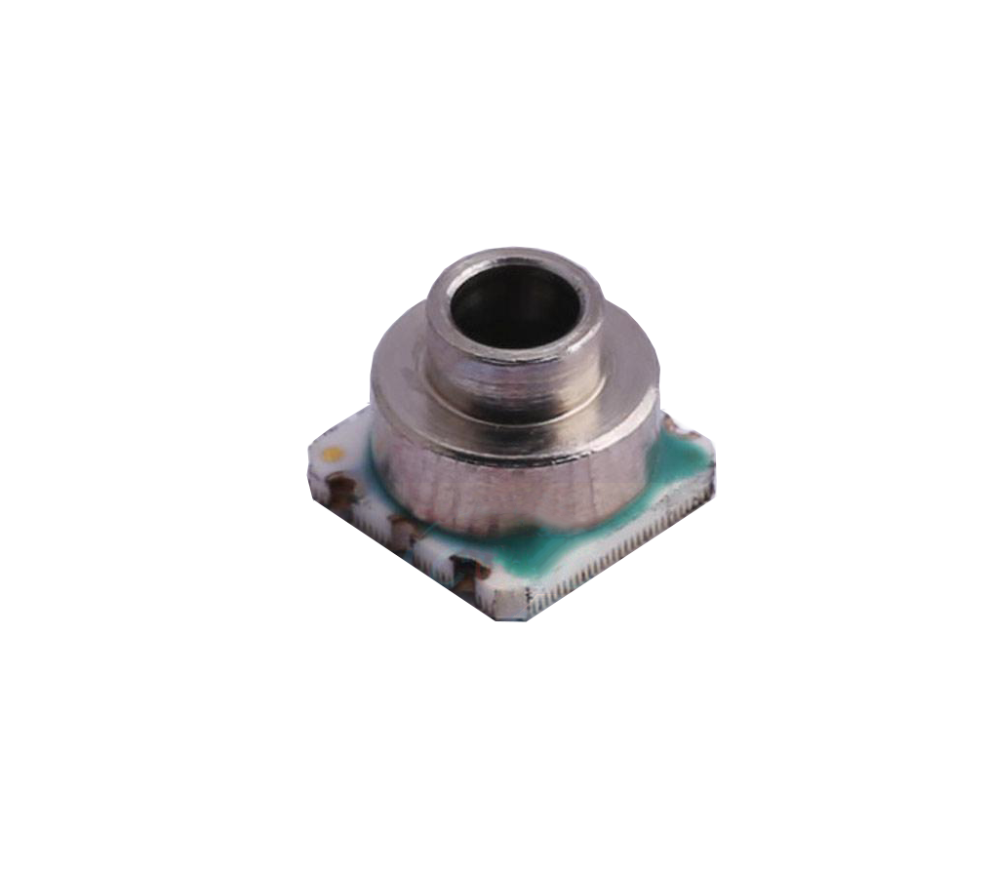
Digital Barometer
Overview  The CPS135B SIP (System-in-a-Package) solution comprises of a resistive bridge type pressure sensor and a 24-bit ADC for high resolution and accurate pressure measurements. The fully calibrated pressure and temperature compensated digital output makes the CPS135B solution simple to use. The CPS135B comprises of an internal calibration logic that provides accurate pressure and temperature measurements to the application via I²C interface. There is no need to separately download internal calibration coefficients and have the host micro-controller conduct complicated compensation calculations.  Applications  - Altimeters  - Portable and Stationary Barometers  - Weather Stations  - GPS Applications  - Hard Disk Drives(HDD)  - Industrial Equipment  - Air Control Systems  - Vacuum Systems |  | Benefits  - Low Power Consumption. Excellent for Battery and Other Low-Power Applications  - External Clock not Required  - High Resistance to Sensing Media  Features  - Factory Calibrated Pressure and Temperature Sensor  - Supply Voltage: 2V to 5.5V(3V @typical)  - Current Consumption: <5uA(One Measurement)  - Sleep State Current: <200nA (25°C)  - Operating Temperature Range: -40°C to +85°C  - Pressure Accuracy: ±0.3kPa (±3.0mbar) @ 25°C  - Temperature Accuracy: ±1.0°C  Interfaces  - I²CTM* Compatible (≤400kHz)  Physical Characteristics  - Small Form Factor, 4.5 x 4.5 x 3.5mm (w x l x h)  - SMD, 6 Lead  - Ceramic Substrate
*I²C TM is a registered trademark of NXP

CPS135B BLOCK DIAGRAM
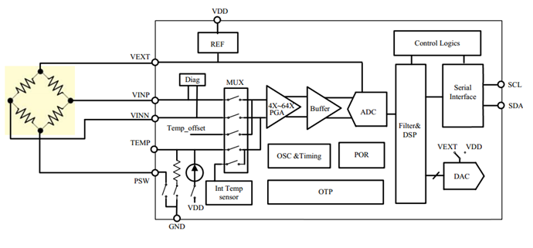

TABLE1: ORDERING INFORMATION
PART NUMBER | OUTPUT MODE | OPERATION MODE |  | PACKAGE
CPS135B | I²C | Sleep |  | 6-Lead SMD
SALES and CONTACT INFORMATION sales@consensic.com
www.consensic.com
United States  Consensic, Inc.  1900 Powell Street,Suite 600  Emeryville California, 94608, USA  Ph: +1 510.588.8735 | China  Wuxi Consensic Electronics Co., Ltd.  No.86,Dicui Road,B5 Building,  Fourth Floor,Room 401,  Wuxi, Jiangsu Province, 214072  Ph: +86 510.85122279  Fax: +86 510.85122259 |  | 无锡康森斯克电子科技有限公司  无锡市滨湖区滴翠路86号太湖智谷科技园  北门B5栋4楼401室  邮编:214072  电话: +86 510.85122279  传真: +86 510.85122259

CONTENTS
1 OPERATING CHARACTERISTICS 6
1.1 ABSOLUTE RATINGS 6
1.2 OPERATING CONDITIONS 6
1.3 ELECTRICAL PARAMETERS 7
2 OPERATION MODES 7
3 OUTPUT MODES 7
3.1 I²C Slave 7
3.2 I²C COMMANDS 8
4 CALCULATING OUTPUT 11
4.1 PRESSURE OUTPUT 11
4.2 TEMPERATURE OUTPUT 11
5 PACKAGE AND ASSEMBLY 12
5.1 PIN ASSEMBLY AND MECHANICAL DRAWING 12
5.2 SOLDERING CONDITIONS 13
6 APPLICATION DIAGRAM 14
7 DOCUMENT HISTORY 14
8 DISCLAIMER 15

LIST OF TABLES
TABLE 1: ORDERING INFORMATION 3
Table 2: I²C COMMANDS 8

LIST OF FIGURES

Figure 1: 7-BIT SLAVE ADDRESS FOLLOWED BY THREE PRESSURE AND TWO TEMPERATURE BYTES 9
FIGURE 2: 7-BIT SLAVE ADDRESS FOLLOWED BY THREE PRESSURE BYTES 10
Figure 3: I²C MEASUREMENT REQUEST COMMAND (0xA) 11

OPERATING CHARACTERISTICS

ABSOLUTE RATINGS
PARAMETER | SYMBOL | CONDITIONS | MIN | TYP | MAX | UNITS
Over Pressure |  |  |  |  | 2X FS | kPa  (bar)
Supply Voltage (with respect to GND) | V_{DD} |  | -0.3 |  | 6.5 | V
Voltages at Analog and Digital I/O Pins | V_{A_IO}  V_{D_IO} |  | -0.3 |  | V_{DD} +0.3 | V
Storage Temperature | T_{STOR} |  | -60 |  | 150 | °C

OPERATING CONDITIONS
PARAMETER | SYMBOL | CONDITIONS | MIN | TYP | MAX | UNITS
PRESSURE SENSOR
Range |  |  | 50  (500) |  | 160  (1600) | kPa  (mbar)
Resolution¹ |  |  |  | 0.01  (0.1) |  | kPa  (mbar)
Accuracy |  | 50 to 160kPa  @25°C | -0.3  (-3.0) | ±0.15  (±1.5) | +0.3  (+3.0) | kPa  (mbar)
 |  | 50 to 160kPa  (0°C to 50°C Verified) | -0.5  (-5.0) | ±0.3  (±3.0) | +0.5  (+5.0) | kPa  (mbar)
Solder Drifts |  |  | -0.2 |  | +0.2 | kPa
TEMPERATURE SENSOR
Range |  |  | -40 |  | 85 | °C
Resolution |  |  |  | 0.003 |  | °C
Accuracy |  | -40°C to 85°C | -1 | ±0.75 | +1 | °C
OPERATION
Supply Voltage to GND² | V_{SUPPLY} |  | 2 | 3.0 | 5.5 | V
Operating Temperature Range |  |  | -40 |  | 85 | °C
I²C Pull-Up Resistors | R_{PU} |  | 1 | 2.2 |  | kΩ
¹Guaranteed by design of 24bits ADC, and calculated according to the range in application.
² Factory calibrated for Pressure and Temperature at 3.0V±10%. Output accuracy will be affected if used outside this range. Other ranges available upon request.

ELECTRICAL PARAMETERS
PARAMETER | SYMBOL | CONDITIONS | MIN | TYP | MAX | UNITS
SUPPLY CURRENT
Supply Current,  average(1)  during conversion(2)  standby(no conversion) | Iavg  Isc  Iss | VDD=3V |  | 3.95  1.5 | 0.2 | µA  mA  uA
ANALOG TO DIGITAL CONVERTER
Resolution | r_{ADC} |  |  |  | 24 | Bit
I²C Clock Frequency | F_{C,I2C} |  |  |  | 400 | kHz

Notes
- Under the assumption of one conversion every second. Conversion means either a pressure or a temperature measurement
- During conversion, the sensor will be switched on to VDD, and after conversion ended, the sensor will automatically be switched off from VDD.

OPERATION MODES
The CPS135B is factory programmed to Sleep Mode. In this mode, the CPS135B remains asleep until the master/host sends a measurement request (MR) before taking sensor measurements. After the CPS135B receives an MR command, it wakes up, runs a full measurement cycle, stores the measurement data in internal registers and then returns to sleep mode again.

OUTPUT MODES

I²C Slave
Two-wire I²C is available for reading sensor measurement data from the CPS135B.
The factory setting for the I²C slave address is 0x6D and the communication is restricted to this address only.
- I²C Address = 0x6D

3.2 I²C COMMANDS
Table 2 details the commands to interface with the device in the I²C mode.

Table 2: I²C COMMANDS
TYPE | DESCRIPTION
Get Data (GD) | Retrieves the sensor measurement data from the internal CPS135B registers*.
Measurement Request (MR) | Wakes up the CPS135B, performs a sensor measurement, stores the sensor measurement data in internal registers and returns to sleep
*Note: GD does not initiate a new measurement. Repeated GD commands will return the same (or stale) sensor measurement data. An MR is required to perform a full sensor measurement cycle to refresh the sensor register data.

The Get Data (GD) command is used to read out data from the CPS135B. With the start of communication (for I²C after reading the slave address) the entire sensor measurement output packet will be loaded in a serial output register. The register will be updated after the communication is finished. The output is always scaled to 24-bits.
The ordering of the bits is “big-endian”.

3.2.1 I²C GET DATA
An I²C Get Data command starts with the 7-bit slave address and the 8th bit = 1 (READ). The device then sends acknowledge (ACK), indicating I²C communication success. The number of data bytes returned by the device is determined by the master, which controls NACK and stop conditions.
Figure 1 displays and example for sending three bytes followed by reading five bytes. The first byte contains the I²C address followed by internal register address(0x06). Then theI²C address is repeated, followed by the slave sending out three pressure bytes and two temperature bytes.
The GD command is used to retrieve the pressure and temperature sensor data after an MR command has been executed.
Note that the two temperature byte codes are formatted in 2’s complement.
Figure 1: 7-BIT SLAVE ADDRESS FOLLOWED BY THREE PRESSURE AND TWO TEMPERATURE BYTES
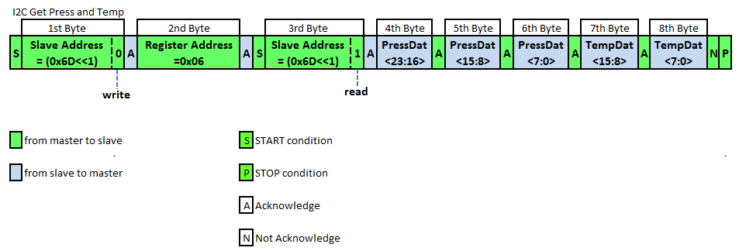

For Pressure data only, the data stream can be terminated after the sixth pressure byte. See Figure 2 below.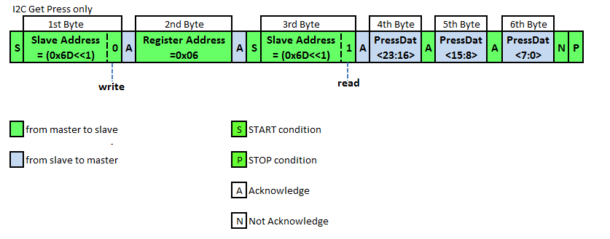
FIGURE 2: 7-BIT SLAVE ADDRESS FOLLOWED BY THREE PRESSURE BYTES

3.2.2 I²C MEASUREMENT REQUEST
The I²C MR is used to wake up the device from Sleep Mode and start a complete sensor measurement cycle, before the device returns to Sleep Mode again. The measurement cycles starts with a pressure measurement followed by a temperature measurement. The sensor measurements are digitized and run through an onboard compensation algorithm before the final measurement values are written to the digital output register. As shown in Figure 3, the communication requires the slave address (0x6D) and a WRITE bit (0) to initiate the MR. This is followed by two bytes; register address (0x30) and measurement (0xA). After the CPS135B responds with the slave ACK, the master terminates the communication with a stop condition.
Sensor measurement conversion time takes approximately 5ms, so MRs should not be sent faster than every 5ms.

Figure 3: I²C MEASUREMENT REQUEST COMMAND (0xA)

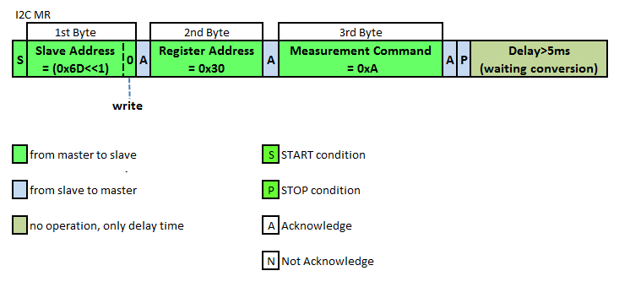

CALCULATING OUTPUT
After retrieving the data, the compensated output can be scaled to real world values by following the equations below.

PRESSURE OUTPUT
An example of the 24-bit compensated pressure with a full scale range of 50 to 160kPa can be calculated as follows:
Pressure [kPa] = (Pressure 3rd Byte [23:16] x 65536+Pressure 2nd Byte [15:8] x 256 + Pressure1st Byte [7:0]) / 2^5/1000

TEMPERATURE OUTPUT
The 16-bit compensated temperature can be calculated as follows:
Positive Temperature [°C] = (Temperature High Byte [15:8] x 256 + Temperature Low Byte [7:0]) / 2^8
Negative Temperature [°C] = (Temperature High Byte [15:8] x 256 + Temperature Low Byte [7:0]-65536) / 2^8

PACKAGE AND ASSEMBLY
The CPS135B is available in a 6-pin SMD package.

PIN ASSEMBLY AND MECHANICAL DRAWING

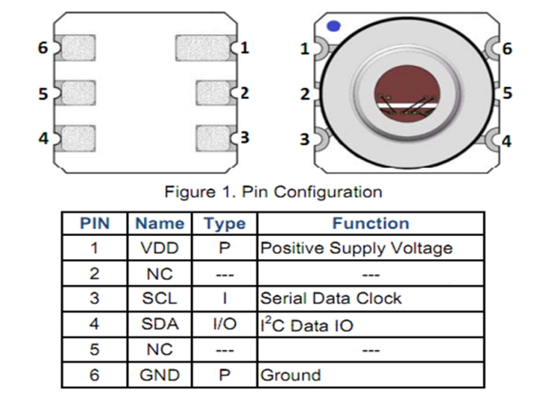
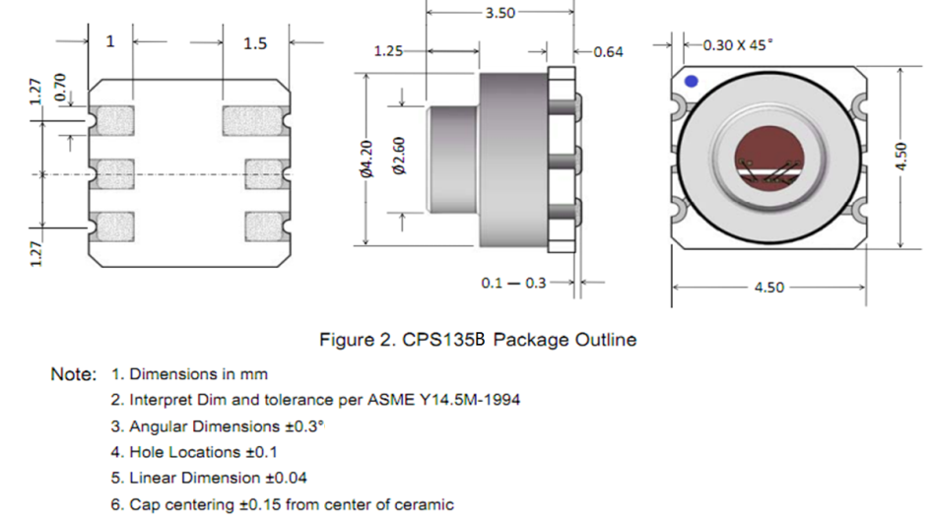

SOLDERING CONDITIONS

TABLE4: PACKAGE REFLOW TEMPERATURE
PARAMETER | CONDITIONS | MIN | TYP | MAX | UNITS
Soldering Peak Temperature | Less than 30 seconds  (JEDEC-STD-020 Standard) |  |  | 260 | °C

APPLICATION DIAGRAM
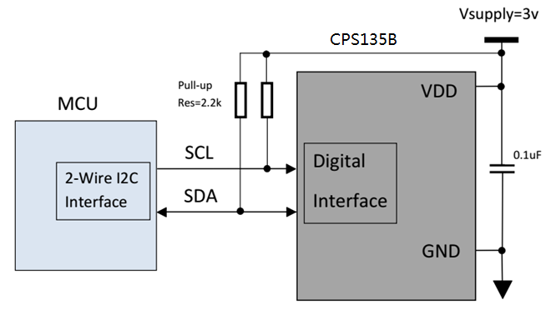

DOCUMENT HISTORY
REVISION | DATE | DESCRIPTION
0.0 | 01-Sep-2016 | Preliminary
1.0 | 10-Oct-2016 | Range change to 50kpa ~160kpa
1.1 | 01-Mar-2021 | Modify company address

DISCLAIMER

Information in this datasheet is provided solely to enable implementation and use of Consensic products. The specifications and characteristics are subject to change without notice. Consensic reserves the right to make changes without further notice to any products herein.
“Typical” parameters provided in this datasheet can and do vary in different applications and actual performance may vary over time. Customers must validate all operating parameters for their application.
Consensic is not responsible for direct, indirect, incidental or consequential damages resulting from any defect, error or failure to perform. In no event, regardless of cause, shall Consensic incur any liability for any damages of any kind, including, but not limited to, any direct, indirect, special, incidental, punitive or consequential damages arising out of, resulting from, or any way connected to the use of the product, whether arising under breach of contract, tort (including negligence), strict liability or otherwise, and whether based on this agreement or otherwise, even if advised of the possibility of such damages, and whether or not injury was sustained by persons or property or otherwise; and whether or not loss was sustained from, or arose out of, the results of, the product, or any services that may be provided by Consensic.
The customer assumes all responsibility and liability for proper and safe handling of the goods. It is the customer’s responsibility to take any and all appropriate precautions with regard to electrostatic discharge. Also be aware that the products herein may not be regulatory compliant or agency certified (FCC, UL, CE, etc.).
No License is granted under any patent right or other intellectual property whatsoever. Consensic assumes no liability for applications assistance, customer product design, software performance, or infringement of patents or any other Intellectual property rights of any kind.

